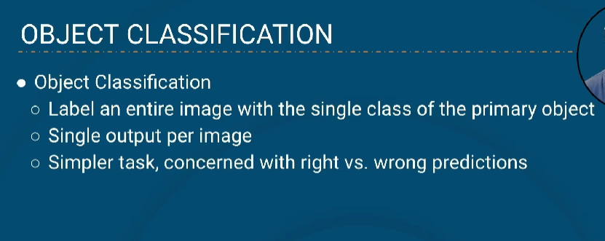
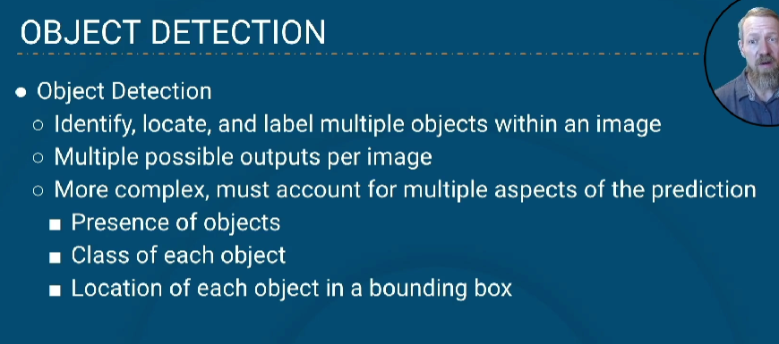
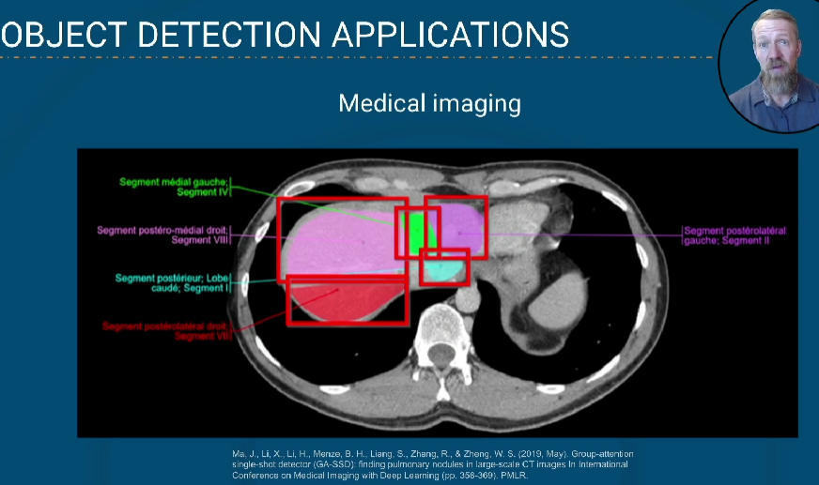
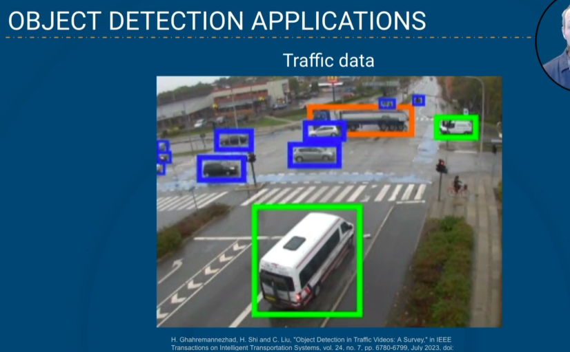
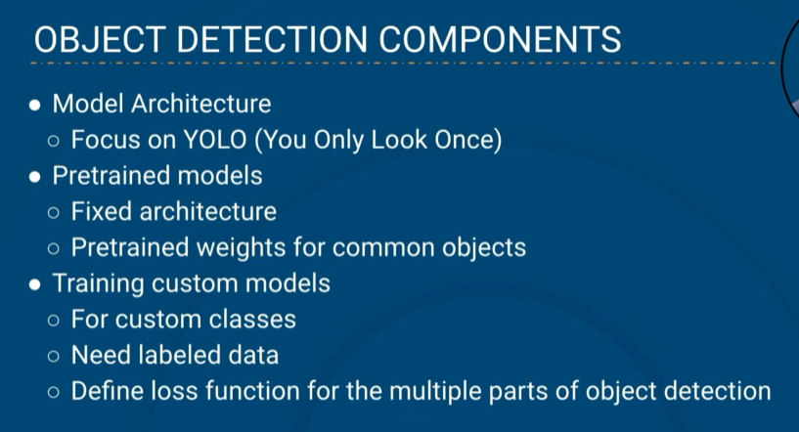

Existing object detection model is not good for processing video image, that will take more time grab all the frames from a video and make analysis on it
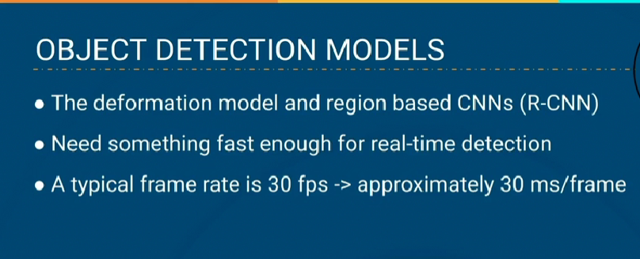
In the image belwo pink is the YOLO model, shows what time it take to make predict compare to other mode(yellow, purple)
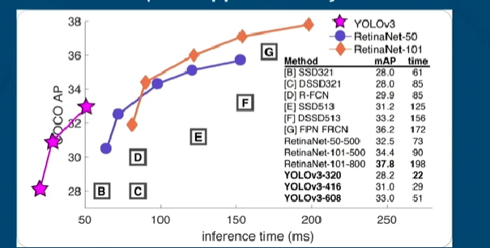
We can see the time spent by YOLO model on the table below
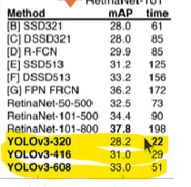
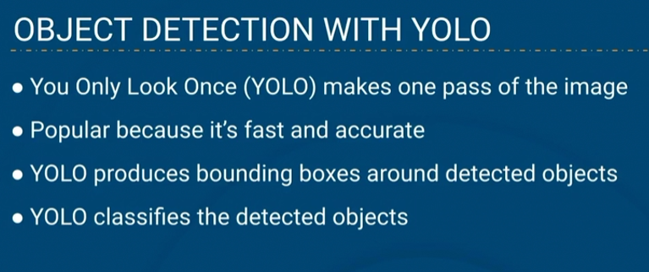
In the below image boxes with number represents the confidience, that is paramter can set when we run model, that value will modifies these confidence value, we can set lower, higher confidence, but in below image we set 50% confidence
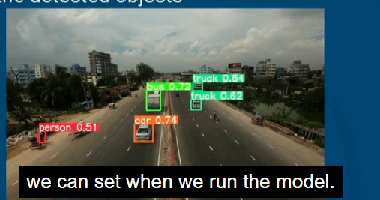
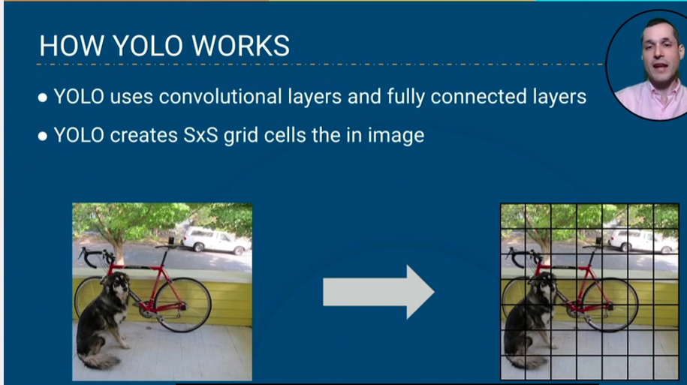

X,y,w,h,c are the parameters sets for
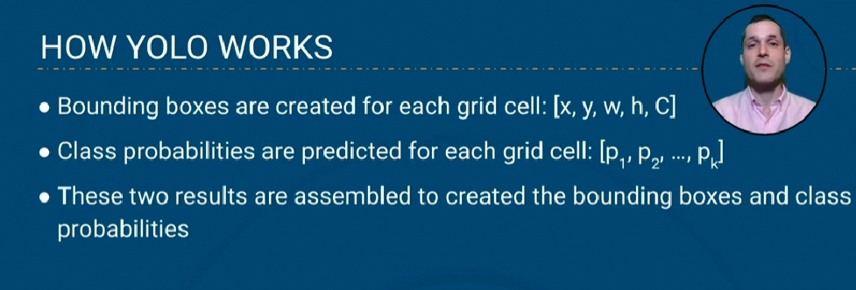
Below is the example image after creating bounding boxes in each grid.
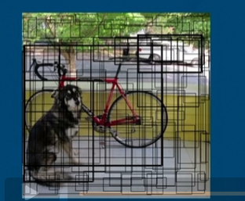
Below is the image for finding class probabilities for each grid, from this probability it take high and that will be the exact output we looking for
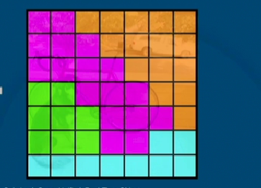
The above are the two output we will got from a model
By combining this two final output will come like the below image
